SUSTAINABLE STAVERTON: HEDGEROW INFORMATION.

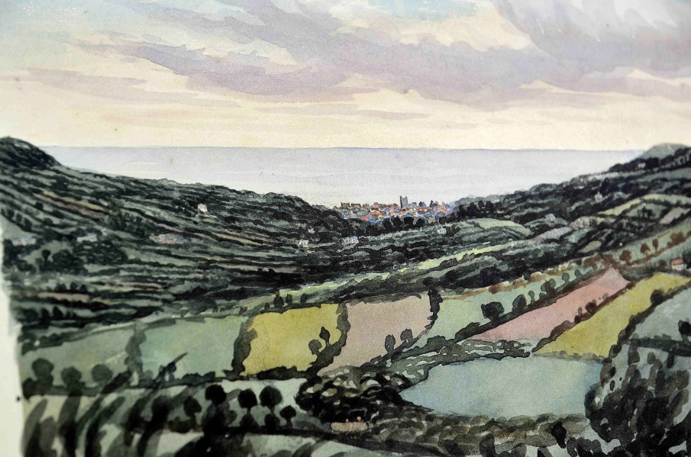
This little painting by Orlando Hutchinson, featuring the land around Sidmouth in Devon (circa 1860) testifies in a vivid manner the former abundance of
hedgerows in the county.

More than a hundred years later Beaford Archive photographer James Ravilious coninued to celebrate Devon’s hedges.

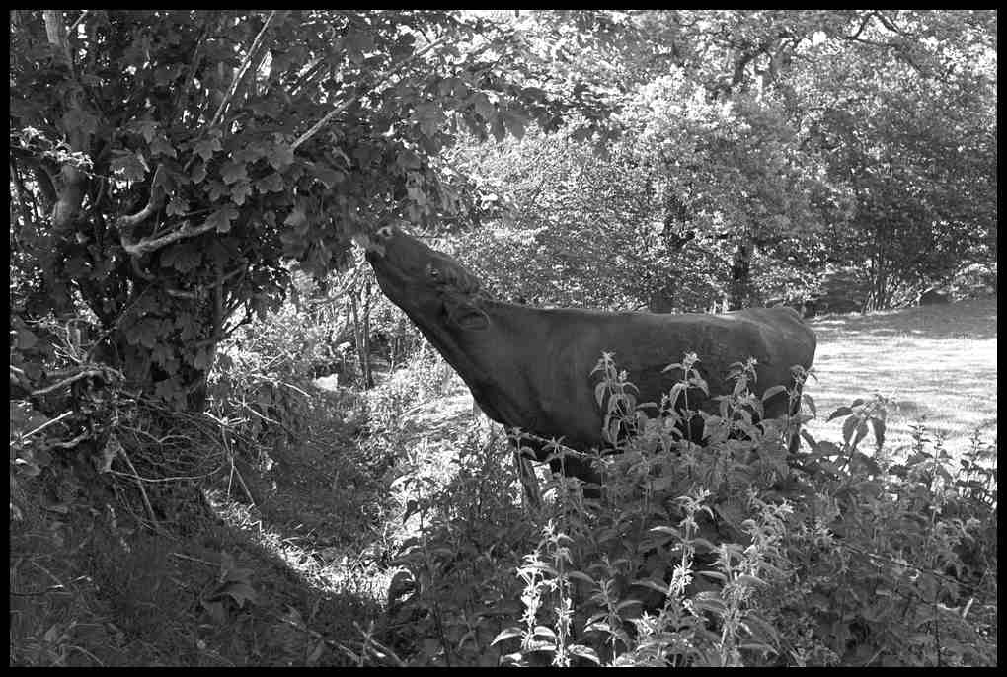
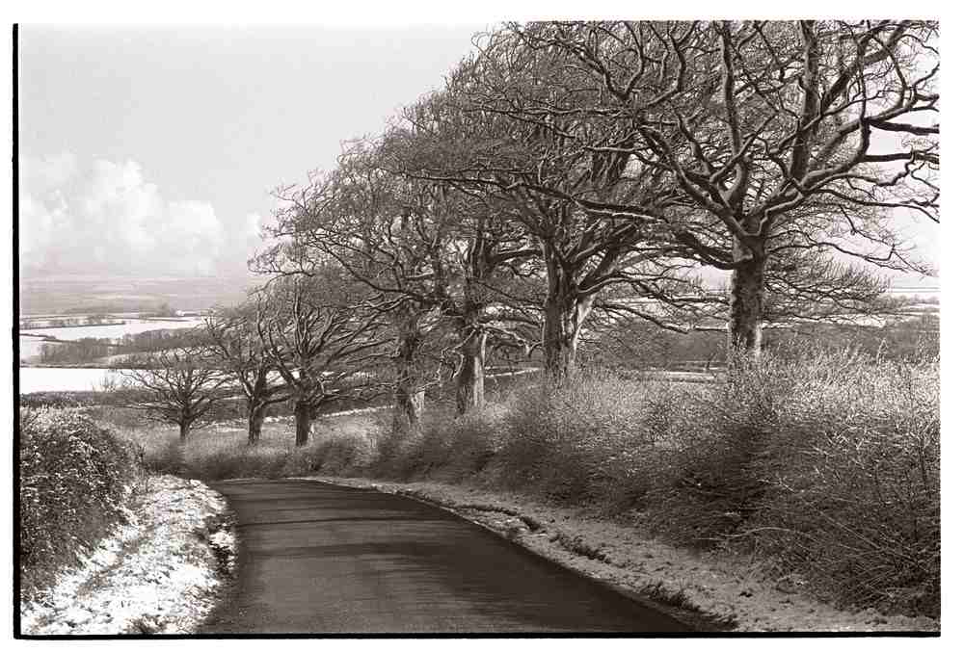

They are the glory of the Devon landscape. Many of them are hundreds of years old. James hoped that by recording this unique landscape it would be preserved for future generations to enjoy.

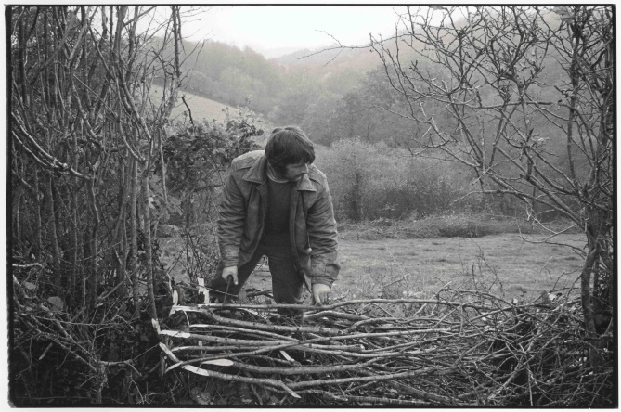
He was also keen to show those who worked to maintain our hedges – their skills and craftsmanship handed down for years created the familiar landscape of stockproof boundaries and wildlife havens that have lasted for centuries.
By the middle of the last century these crafts were being rapidly being replaced with the tractor driven flail cutter now so familiar to us all. Our hedgerows were no longer considered the pride of the countryside, but an obstacle to farm machinery and yet another resource to be managed in the fastest way possible. A woman in Cornwall describes how people felt when they first encountered a flail cutter – I became accustomed to seeing ordinary sane adults in tears of anguish and fraught with frustration and fury every time the council flails went by. One perfectly sensible down to earth woman said to me “I feel as if a great joy has been struck dead in my heart.” Another said, with too much clear sighted truth “The hedges will never recover from this.”

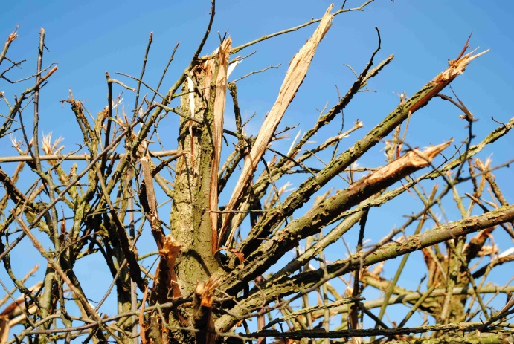
It’s hard to know just how much permanent damage flailing causes, but a recent item on TV about the Holkum Estate in Norfolk, showed gaps in the hedgerow where some of the vegetation had simply given up under the stress of over zealous flailing techniques.

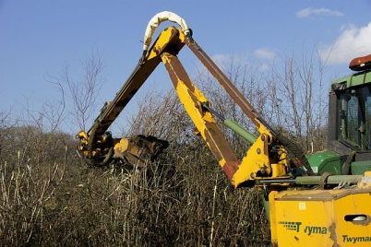
Flail cut hedges are only as good as the driver in the tractor. The success of flailing depends on the speed of the tractor, the sharpness of the flail and changing the height of the cut each time. It should be done no more than once every 2-3 years. One technique is to trim the sides every year, but the tops every 2-3 years.
The bigger the hedge, the more wildlife it can support. It is estimated that each year a hedgerow is left uncut it will gain two species of breeding bird.

Devon Wildlife Trust stresses the importance of hedgerows: As well as providing food and shelter, hedgerows create vital links across the countryside, helping wildlife to move freely about and keeping populations healthy. They’re also good for the landscape and the wider environment, preventing soil erosion, capturing pollutants such as fertilisers and pesticides running off fields, assisting with water regulation, storing carbon to help combat climate change, and providing homes for predators of many pest species, as well as sheltering livestock.

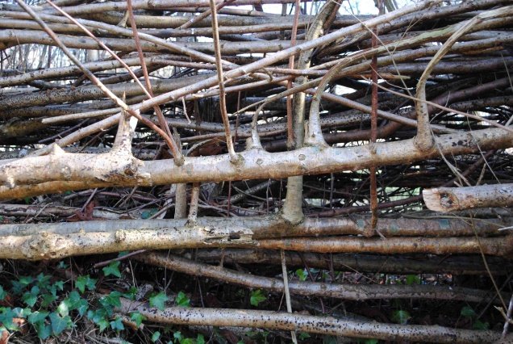
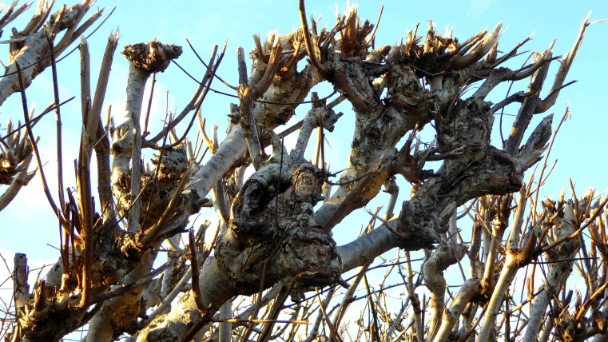

It doesn’t take an expert to see that a properly maintained hedge with its density of healthy vegetation has far greater potential for carbon sequestration and a thriving wildlife population. Simply ask yourself if you were a nesting bird or dormouse which one would you choose to set up home? Hedgerows provide havens for birds, badgers, voles, moles, field and harvest mice, stoats, weasels, shrews and countless invertebrates. In turn these are preyed upon by bats, owls and kestrels in a complex web of life that feeds in the disorderly tangle of shrubs and trees.

Following the declaration of a Climate and Ecological Emergency we have seen numerous imaginative tree planting projects in order to draw down carbon dioxide from the atmosphere. This is highly encouraging, but at the same time, we should also be maintaining and enhancing our mature trees and hedgerows which have served us well for hundreds of years. (Some hedgerows can be traced back to the Bronze Age). In the short term a mature hedge with ancient trees will sequester far more CO2 than newly planted saplings.

Hedgelink welcomes the proposal by government scientists that extending hedges by 40% is one of the key changes needed to reach net zero by 2050. The last hedgerow survey, in 2007, recorded 500,000km (312,500 miles) of hedgerows in the UK. Extending this by 40% would require a further 200,000km of new hedges. Hedges not only sequester carbon in woody growth above ground, but in roots, leaf litter and other soil organic matter at and below ground level. According to Hedgelink, by capturing eroding soil, hedgerows can increase soil organic carbon for up to 60m uphill.

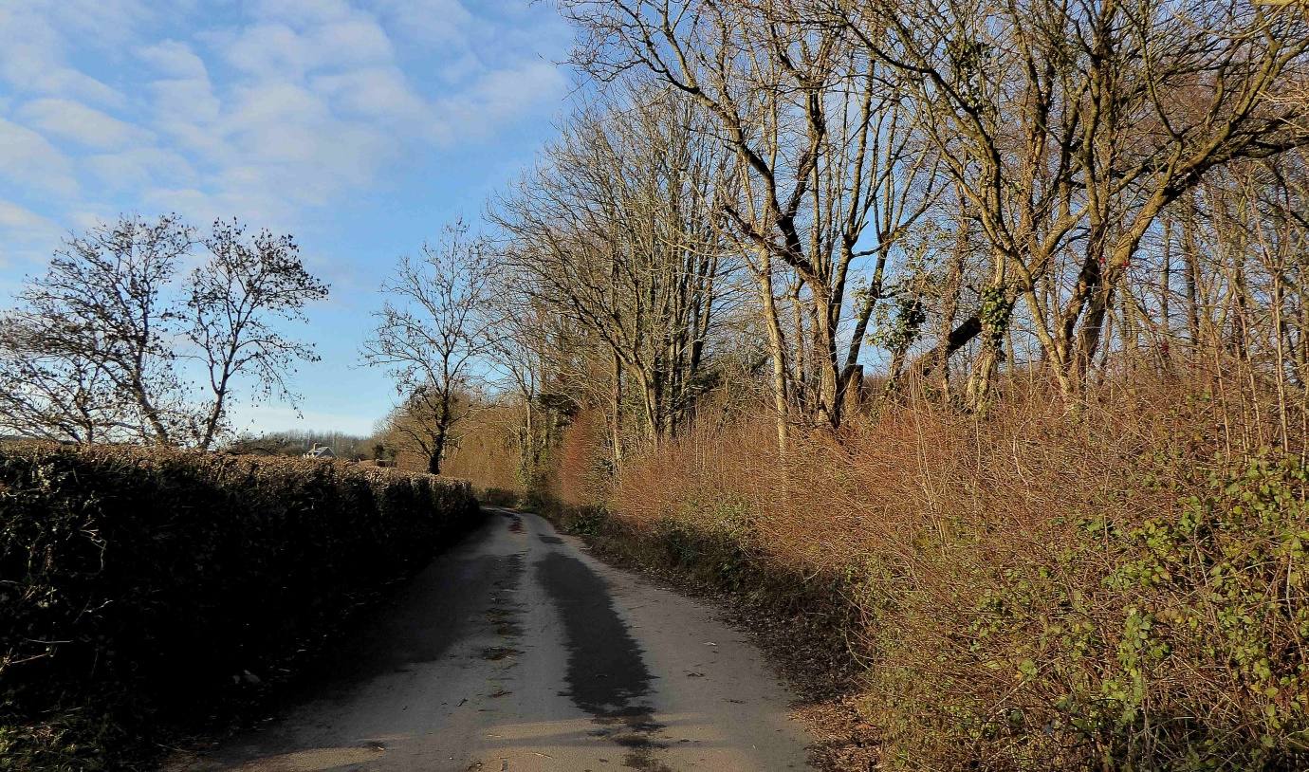

Compare the two hedges in this picture on the road out of Staverton past Newtake towards Landscove. On the right trees are left standing and there is dense vegetation to capture carbon and enhance wildlife. Then take a closer look at the hedge on the left where trees are flailed almost beyond recognition:
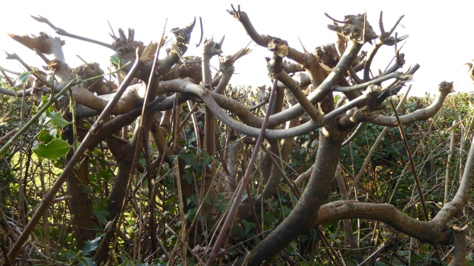
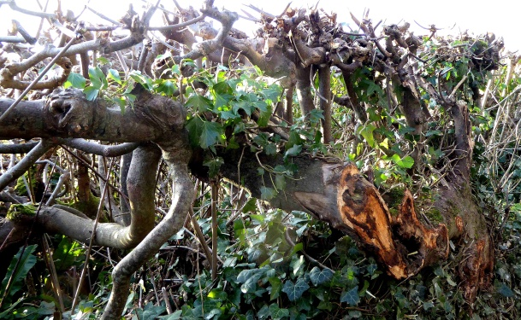

This kind of hedge management offers much reduced cover for wildlife, and far less biomass for carbon sequestration. In the long term we have little idea how long this severe flailing can continue before constant stress causes the vegetation to simply ‘give up’. Ironically where the hedge is poorly managed it often needs a barbed wire fence erected alongside in order to make it stockproof!

Then consider the hedge density and the unnatural gnarled bulbous growth on what nature intended as a straight stem:

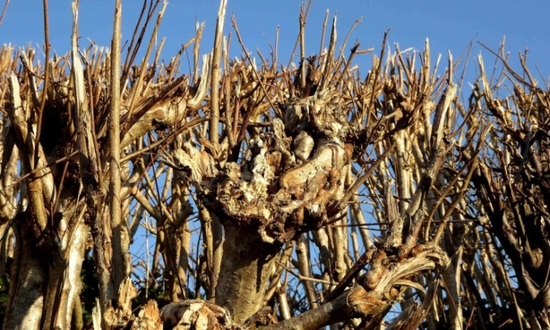
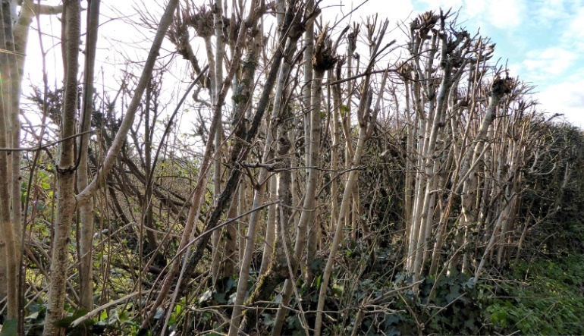

Two things immediately spring to mind. Are our hedgerows best served by this kind of treatment, and should an effort be made to remedy this situation? Undoubtedly the best solution would be to train people and pay them to lay hedges properly. This may not be so difficult. I worked as a volunteer at Slapton Ley Nature Reserve for ten years, and there was never any shortage of volunteers willing to put in hard graft to enhance nature. Even more so if they were trained and paid. Moreover it could provide much needed skilled winter employment for those who work in the tourist industry. There is no doubt that a properly laid and maintained hedgerow has so many advantages, and only needs maintenance every 5 years.

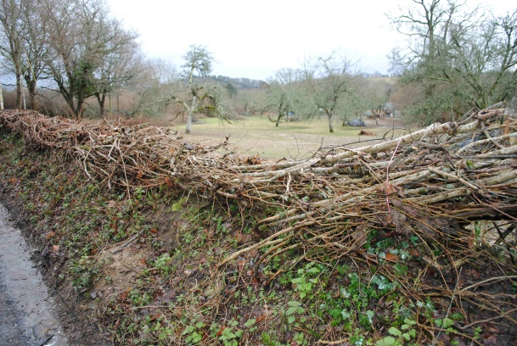
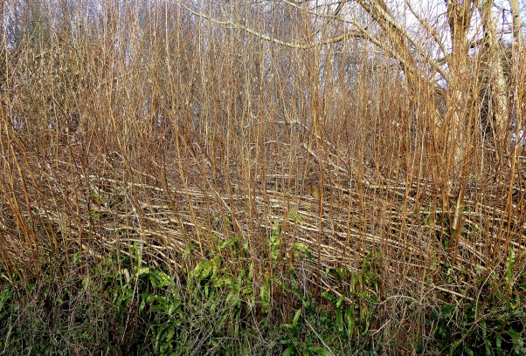

However being realistic it is doubtful whether flailing can be replaced anytime soon. So probably the best we can do immediately is to encourage a regime of cutting which is less damaging – sharpness of flail, speed of tractor, changes of height, and cutting once every two to three years.

In addition flailing also incurs a hidden cost. The cuttings get left on the road where they block drains and cause punctures in bicycle tyres. In time with compression by vehicle tyres they create a growing medium for grass. This in turn cracks up the road surface which needs replacing. In the end we all pay.

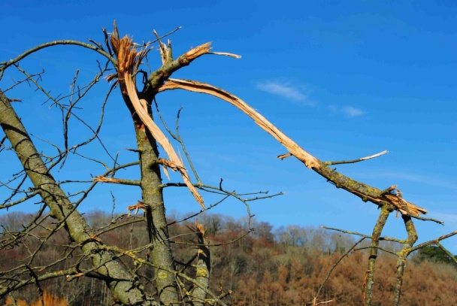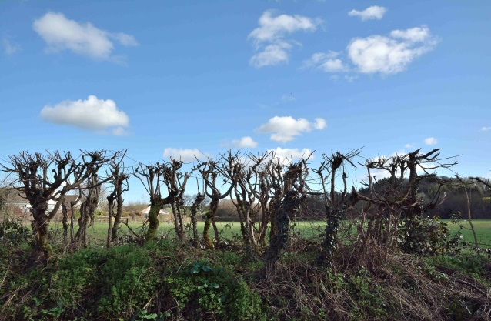

All the pictures above are from Devon, but its representative of what’s happening all over the UK. When managing our heritage we should be mindful of a quote by John Ruskin – There is no wealth but life.

Malcolm Baldwin. February 2021. Staverton Devon.

Sources: Hedgelink; Devon Wildlife Trust; Beaford Archive; The Devon Hedge Group; Devon Hedgerow project; Marion Shoard – The Theft of the Countryside; The Climate Change Committee report.

